Eval 1 - Question 4 - Recursive Function
Explanation: This recursive function calculates the sum of the individual digits making up the input integer.
Activation Diagram for doThis(25):
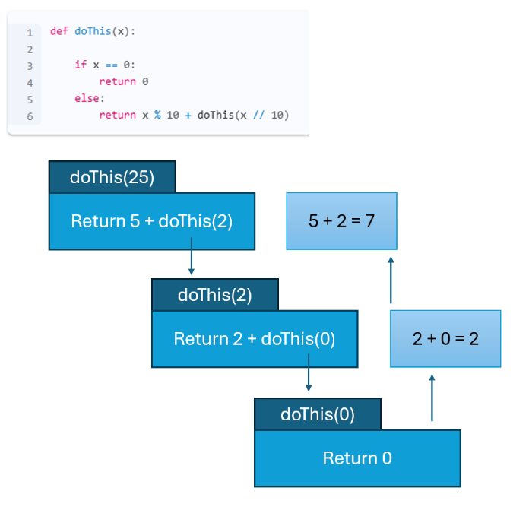
Activation Diagram for doThis(3741):
